**Keycloak Configuration  
  
1. Main client settings tab  
Note 1:**Please, replace <url> with your actual URL.  
**Note 2:** Ensure to include "http" instead "https" in the **Valid Redirect URIs** field.  
  
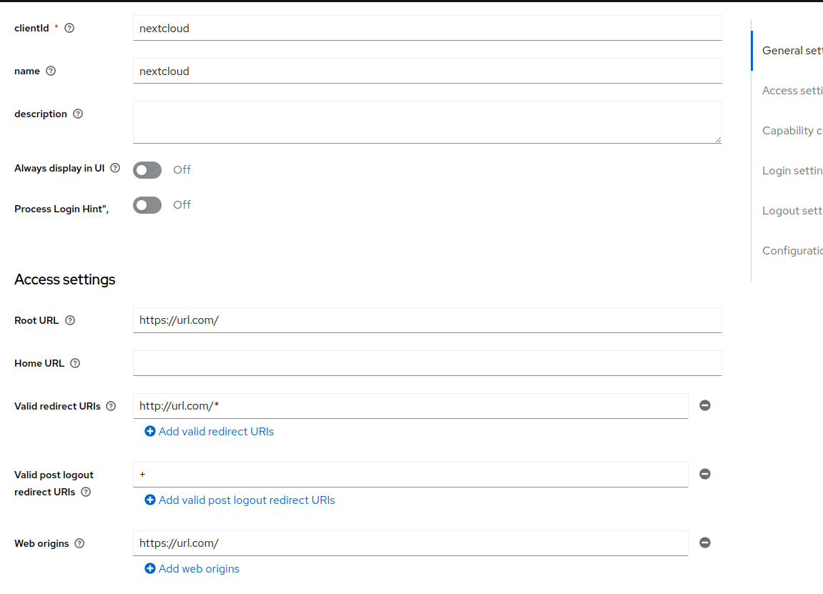

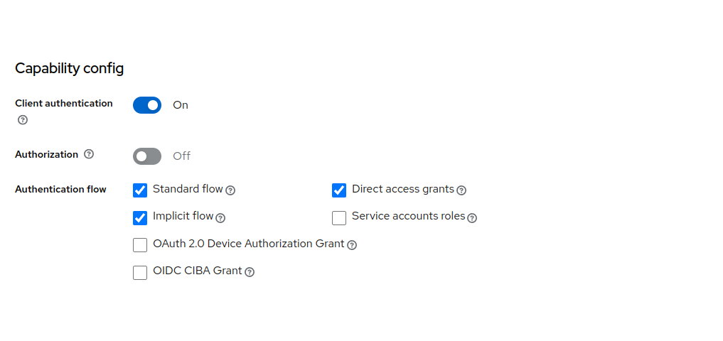

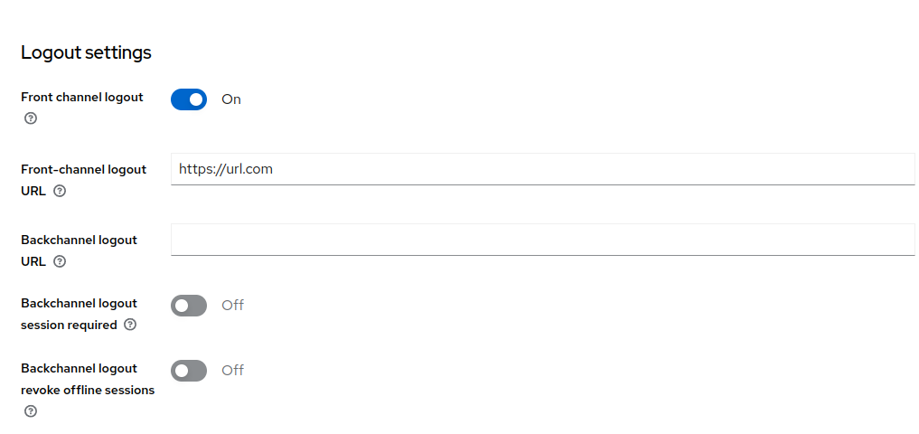**2. Client > Client Scopes**2.a - Go to the client dedicated scope  
2.b - If **client roles** mapper does not exists, add mapper following: Add mapper > from predefined mappers > select client roles  
 **Client roles configuration:  
NOTE:** update client ID with your actual client ID

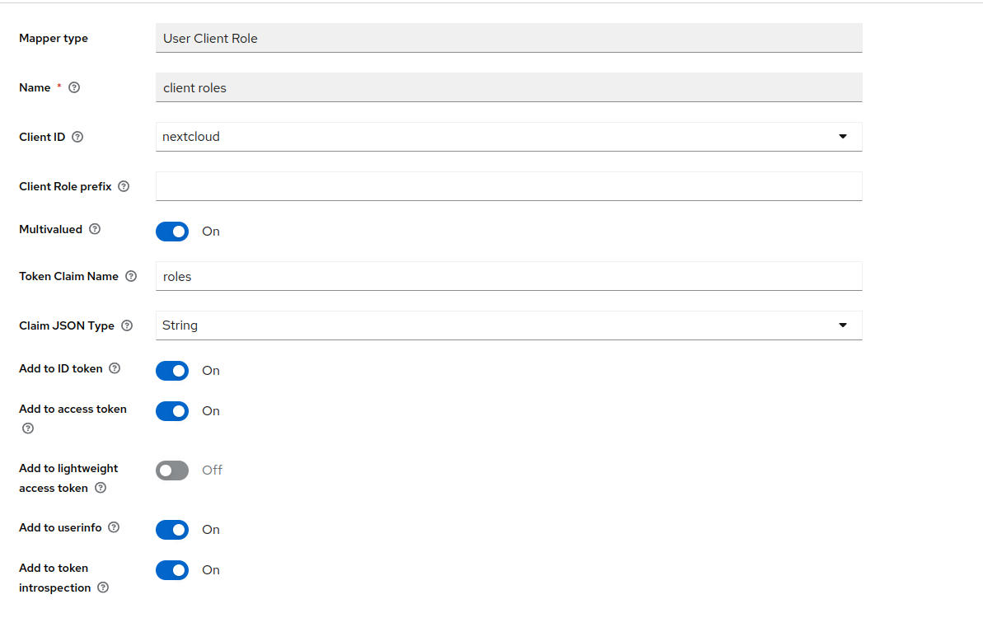

**3. Create roles**To add different types of access, we will define roles through Keycloak.  
  
3.a - Go to Client > Roles > Create roles. You can create as many roles as you need, but for this guide, we will focus on the admin role only  
  
**3. Create groups**Users will have access to a group, and this group will have a role attached to it.  
  
3.a - On the left tab, hit groups. Create a group "nextcloud_admins"  
3. Go to Role mapping > Assign Role > Filter by clients > select admin role

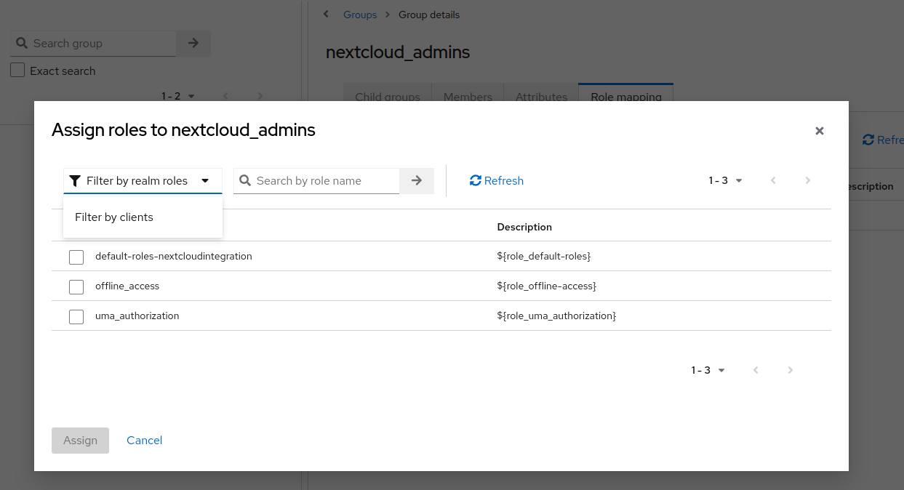

**NextCloud Configuration**  
1. Go to the social login app administration configuration   
2. Check 'Prevent creating an account if the email address exists in another account'  
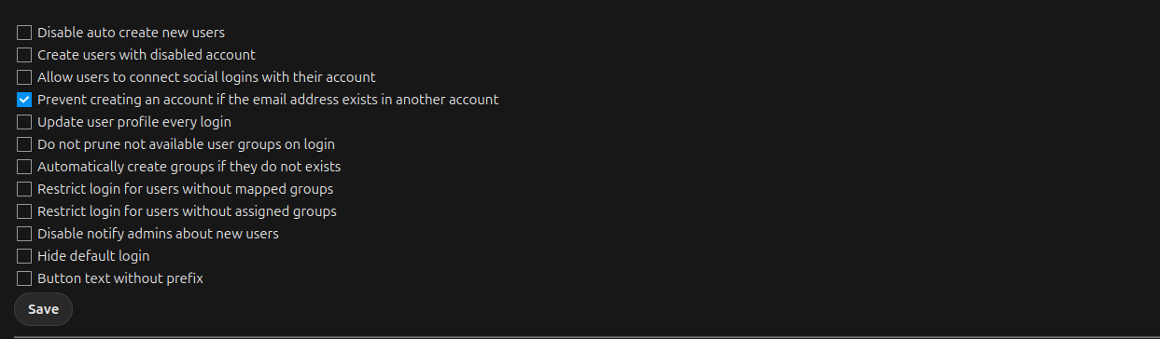

2. a Save the configuration  
  
3. Retrieve realm information  
Back to keycloak, go to configure > realm settings

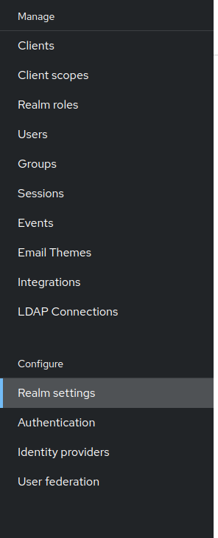  
  
4. Hit the "+" button in "Custom OpenID Connect"  
- Apply the configuration  
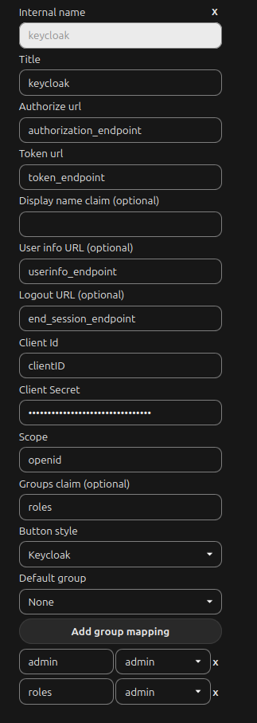

**NOTE:**Make sure to have the roles configured in both Keycloak and Nextcloud. The assignment of roles will be done through group mapping.  
4.a Save the configuration

**Note**: to set up users, go to keycloak > user > add users